<Chocoholics Anonymous > (<ChocAn>)

Use Case Summary Document

Version No. <1.0>

Project Document Revision History
VersionNumber | Date | Revision Author | Description of Revision
1.0 | 06/16/2018 | Ali Tarraf, Ali Al-mugoter, Hassan Harajly, Mohamed Fawaz | Planned and completed Entire Use Case Summary

Table of Contents
1. Introduction 4
2. Project/Application Actors 4
3. Use Case List ……………………………………………………………………………….…………............. 5
4. Use Case Diagram(s)………...……………………………………………......……………………………... 5
5. Use Case Summary …………………………………………………………………………………………… 6
6. Use Case Summary Review and Signoff ……………………………………………………………………... 8
_____________________________________________________________________________________________

Introduction
This document captures BUSINESS requirements at a high level by identifying ALL the use cases in a project/application.
Write a few paragraphs describing the purpose of the project/application in the Introduction.
This project is creating a database center to connect all components of the organization together. This will increase productivity of the current state of the company. Some components of the organization might need to be removed or altered to work for added functionality. We expect to add two new functionalities to the project which may result in deliverables being altered or removed completely. The first milestone will be to have the project approved. The second will be getting the two added functionalities approved. The third would be finalizing all documentation with the two functionalities to be added. The fourth will be completing objective 1, 2, 3, and 4. The fifth will be to complete database center. The sixth will be to test the datacenter with all components of the organization. The final milestone will be to launch the project.
The primary goal of this project is to make the chocAn company more efficient in their day to day processes. First off the providers currently handle all billing and paperwork manually, our aim is to delegate all “busy” work to a datacenter in order to make the providers job easier. In the current state of the company the provider takes to long with patients verifying membership as well as logging all necessary information manually which in turn reduces the likelihood that a patient will reschedule an appointment, by making it easier for the provider we hope to increase patient adherence in the long term.

Project/Application Actors
An actor is someone or something (e.g. application system) outside the system or business that interacts with the application. List the actors involved in ANY use case. Actors should be a person, system, or time.

Actor Name | Description
Acme Financial | A third party responsible for updating member subscription to the data center based on receiving the customers payment.
EFT | A third party responsible for compensating providers for the services they provide to members.
Manager | An employee of the organization that has the ability to view member/provider records and receives weekly reports.
Member | A customer with a membership status with the organization who receives services.
Operator | An employee at the organization that interacts with customers or providers and is able to edit customer/provider information when data center is in interactive mode.
Provider | An employee of the organization and provides services to members.
Time | Interacts with time dependent functionalities.

Use Case List
List ALL use cases identified for the project/application.
- Members card is scanned at provider terminal
- Provider provides member with service
- Operator updates/adds/deletes member records
- Operator updates/adds/removes provider records
- Manager requests reports.
- EFT receives weekly provider compensation data
- Acme updates membership status of member
- Weekly reports are sent
- Interactive mode enabled at 8am
- Interactive mode turned off at 5pm

Use Case Diagram(s)
Show diagram(s) that - ALL actors and ALL use cases identified in sections 2 and 3 must be represented somewhere in the diagram(s). IF multiple use case diagrams are created because of groupings of business functionality assign a number and name to each diagram for ease of reference.
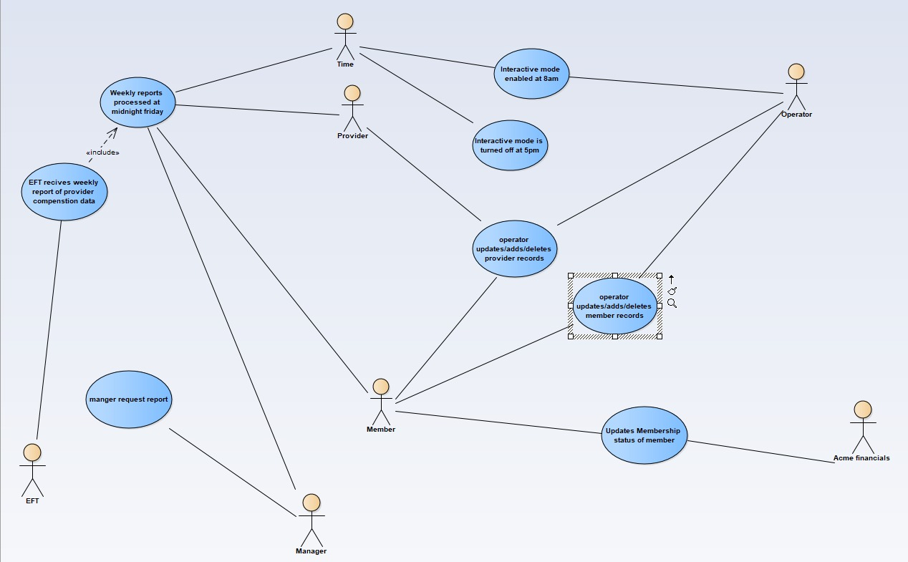
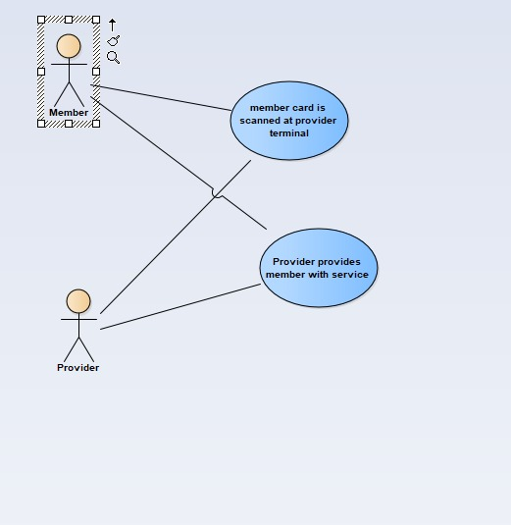

Use Case Summary
For each use case include: Introduction of use case (one paragraph, will also be “introduction” to individual use case specification document), use case diagram number and name reference (if exists), list of main actors and list of secondary actors (these MUST match the lists in the individual use case specification document).

- Members card is scanned at provider terminal
  - Member visits provider and scans card at provider terminal. Provider terminal dials data center to verify member status. If membership status is verified the provider will be able to provide the member with the service.
  - Diagram 2
  - Main actors: member & provider
- Provider provides member with service
  - Provider provides service for verified member. Provider then scans card or enters in member number. After membership is verified again the provider enters in the date and the service code from the provider directory. The service code is validated and the name appears, if its not validated and error appears. Provider can choose to enter in service description. After all required information is filled, the service record is logged to the data center.
  - Diagram 2
  - Main actors: member and provider
- Operator updates/adds/deletes member records
  - Operator communicates with members regarding their accounts. The Operator has the ability to update, add, or remove customer records. They can do this by using the interactive mode of the data center that runs at 8am every day until 5pm.
  - Diagram 1
  - Main actors: member & provider

- Operator updates/adds/removes provider records
  - Operator communicates with providers regarding their records. The Operator has the ability to update, add, or remove provider records. They are able to do this using the interactive mode of the data center. And the member has the ability to contact the operator to modify their provider records.
  - Diagram 1
  - Main actors: member, provider and operator
- Manager requests reports.
  - Data center contains weekly reports of services provided to members and sent to the manager. The Manager is able able to connect to the data center through their terminal. Each report can be run individually at the request of a ChocAn manager at any time during the week.
  - Diagram 1
  - Main actors: Manager
- EFT receives weekly provider compensation data
  - Every week the 3rd party EFT software connects to our datacenter, when the connection is established the EFT system queries our data in order to get information on provider compensation. When the data is gathered they will handle all payments to providers for their services rendered
  - Diagram 1
  - Main Actor: EFT
- Acme updates membership status of member
  - ACME is responsible for handling the billing of the monthly membership fee, when ACME successfully receives payment for the members fee then they change the status accordingly, if they don’t receive payment then they change the members status to suspended. They will establish a connection with our system and modify the member status to reflect if they are an active member or not.
  - Diagram 1
  - Main actors: Acme financials, Member.
- Weekly reports are sent
  - Every week at Friday midnight the reports are processed at the data center, they are printed and sent out, every week members that had services done with the company will be sent a report with a description of the visit, And providers receive reports with a detailed description of the services they rendered in the last week.
  - Diagram 1
  - Main actors:provider, member and manager.
- During the day data center interactive mode is enabled
  - During the day at 8am the system goes into interactive mode, in interactive mode the system grants operators the ability add new members to ChocAn, or to remove members who quit, and to update member records. At 5 Pm the systems interactive mode is turned off at the end of the work day,
  - Diagram 1
  - Main Actors: Time and operator

Use Case Summary Review and Signoff
Review and Signoff of the Use Case Summary
Name | Project Team Role | Signature | Date
Ali Tarraf | (Team Lead) Software Engineer | AT | 06/16/2018
Ali Al-mugoter | Software Engineer | AA | 06/16/2018
Mohamed Fawaz | Software Engineer | MF | 06/16/2018
Hassan Harajly | Software Engineer | HH | 06/16/2018

